Chapter 18, Solution 42.
By current division, 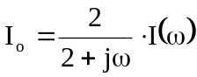
(a) For i(t) = 5 sgn (t),
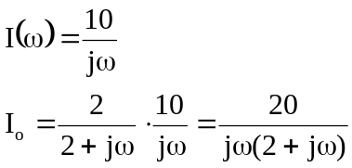
Let 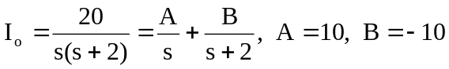
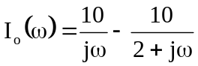
i_{o}(t) = 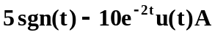

1
t
i’(t)
4δ(t)
–4δ(t–1)
1
t
i(t)
4
(b)

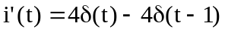
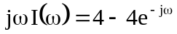
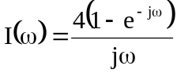
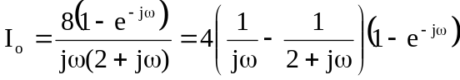
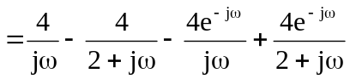
i_{o}(t) =

